A F&B manager wants to determine whether there is any significant difference in the diameter of the cutlet between two units. A randomly selected sample of cutlets was collected from both units and measured? Analyze the data and draw inferences at 5% significance level. Please state the assumptions and tests that you carried out to check validity of the assumptions.

Minitab File : Cutlets.mtw

**Ans :**

**R Code :**

## Hypothesis Testing

########## Cutlets Data Set #########

Cutlets <- read.csv('D:\\Data Science\\Excelr\\Assignments\\Assignment\\Hypothesis Testing\\Cutlets.csv')

x <- Cutlets$Unit.A

y <- Cutlets$Unit.B

boxplot(x)

boxplot(y)

hist(x)

hist(y)

shapiro.test(x)

shapiro.test(y)

var.test(x,y)

t.test(x,y, alternative="two.sided",conf.level = 0.95)

**Results :**

> shapiro.test(x)

Shapiro-Wilk normality test

data: x

W = 0.96495, p-value = 0.32

> shapiro.test(y)

Shapiro-Wilk normality test

data: y

W = 0.97273, p-value = 0.5225

> var.test(x,y)

F test to compare two variances

data: x and y

F = 0.70536, num df = 34, denom df = 34, p-value = 0.3136

alternative hypothesis: true ratio of variances is not equal to 1

95 percent confidence interval:

0.3560436 1.3974120

sample estimates:

ratio of variances

0.7053649

> t.test(x,y, alternative="two.sided",conf.level = 0.95)

Welch Two Sample t-test

data: x and y

t = 0.72287, df = 66.029, p-value = 0.4723

alternative hypothesis: true difference in means is not equal to 0

95 percent confidence interval:

-0.09654633 0.20613490

sample estimates:

mean of x mean of y

7.019091 6.964297

**Plots :**

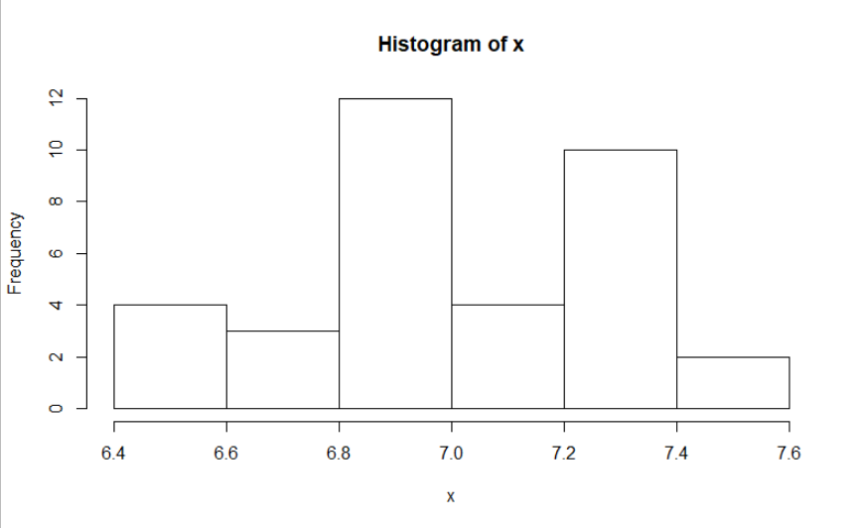

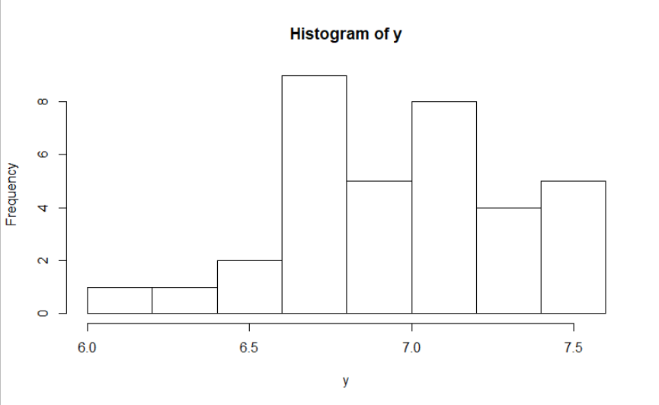

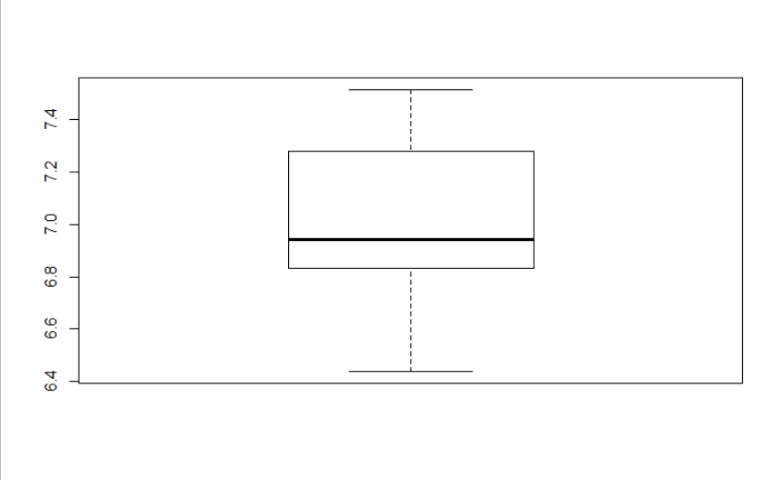

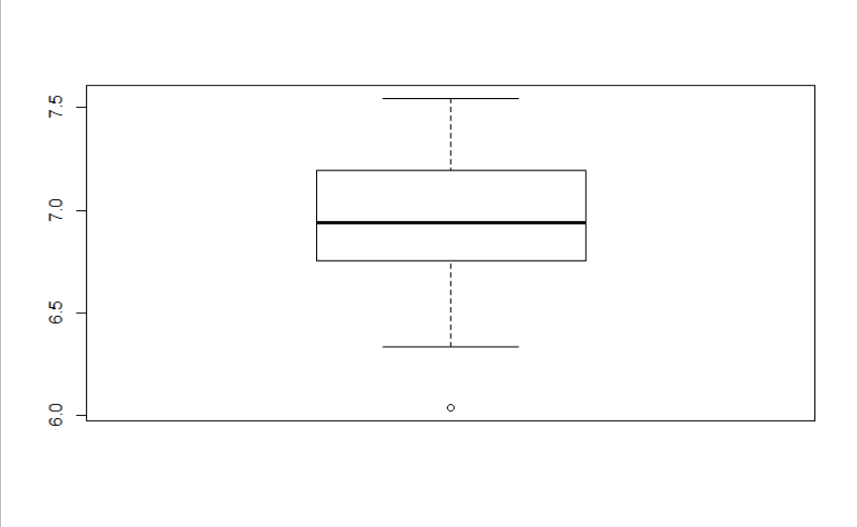

**Inference :**

The assumptions were as below :

Ho = Diameters of Cutlets from Unit A & B are not different.

Ha = Diameters of Cutlets from Unit A & B are having significant difference.

From the t.test we got p-value greater than 0.05 i.e. 0.4723.

Hence, we accept the null Hypothesis.